Could you be a Trustee with Cambourne Youth Partnership?

About us
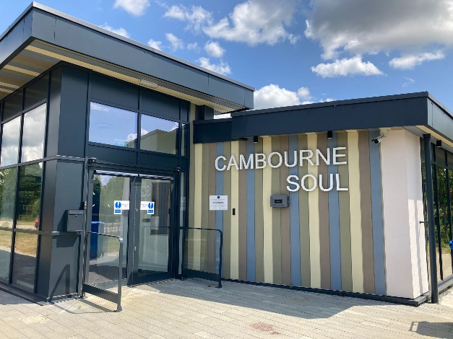
Cambourne Youth Partnership (CYP) is a grassroots charity that enables work with young people, from all cultures and backgrounds, in Cambourne. Through nurturing trusted relationships, we develop positive activities, provide care & advice, and facilitate learning & skills growth.
We aim to provide activities for young people in a safe, healthy and welcoming environment. The main venue for activities is the Cambourne Soul building which belongs to Cambourne Town Council; they are very supportive of CYP’s work.
Through nurturing trusted relationships, we develop positive activities, provide care & advice, and facilitate learning & skills growth.
CYP is supported by Romsey Mill to deliver youth work activities and support within Cambourne. Romsey Mill is a Cambridgeshire charity partnering with a diverse range of community groups, local authorities, schools, colleges, charities, businesses and other organisations.
About you
Whether you’re considering volunteering as a trustee for the first time or you’ve had prior experience, we want to hear from you. Being a great trustee isn’t about being the expert or always having the right answer. It’s about teamworking and being committed to helping to grow and sustain CYP’s positive, purposeful work in Cambourne.
We are particularly looking for new trustees who have knowledge, experience and skills in any of the following areas:
- Business and / or community connections in Cambourne
- Finance / Bookkeeping
- Working with young people
- Fundraising
- Supporting volunteers
What does a Trustee do?
Trustees work as a group with collective responsibility for ensuring that Cambourne Youth Partnership fulfils its purposes. Trustees support our small team of employed youth workers and volunteers, reviewing activities on a regular basis. Championing and promoting Cambourne Youth Partnership is also an important part of the role.
As a Trustee you will have the opportunity to:
- Grow the wellbeing & life chances of young people
- Develop new skills, with induction & training
- Influence and shape community development
- Network and grow relational connections
The expected time commitment is to four or five Trustee meetings (usually in the evening) each year alongside joining in with opportunities to support at events and represent CYP.
What next?
For more information, please go to https://www.cambournesoul.co.uk/
To arrange an informal chat, please contact any CYP Trustee you know already or message our Chair of Trustees, Nigel Taylor nigelrtaylor52@gmail.com

